34.78: For the water-benzene interface to get the apparent water depth: 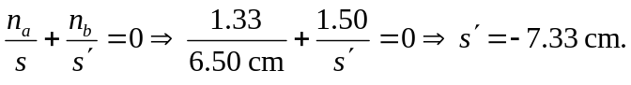
For the benzene-air interface, to get the total apparent distance to the bottom:
